**Setup for iOS**

1. Begin by visiting the App Store

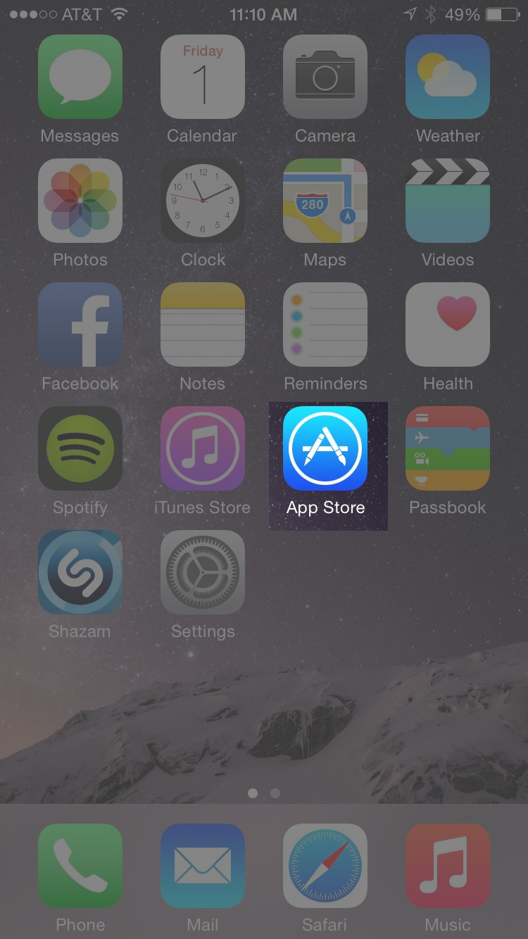

2. Search for and download the free app “TestFlight”

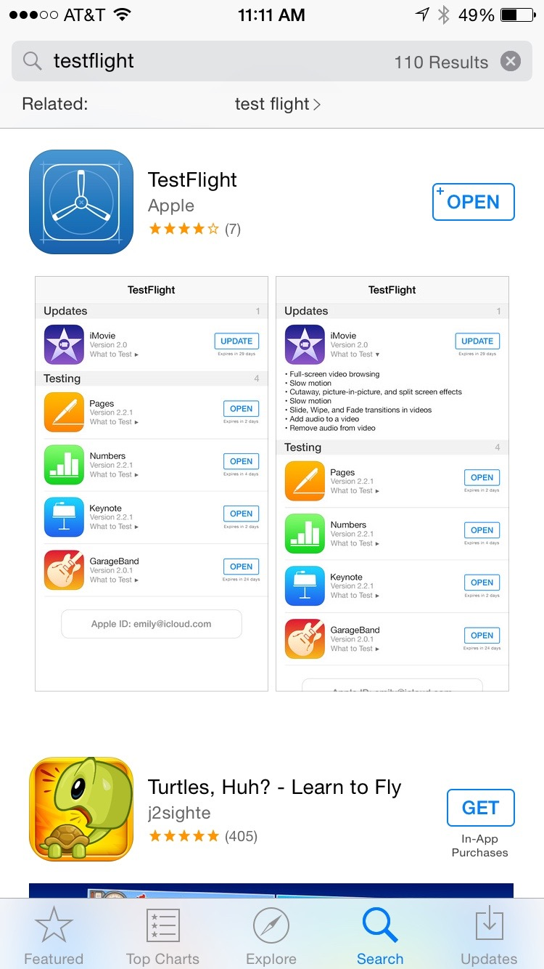

3. Check your email for an email from **iTunes Store** with a subject of “Welcome New iTunes Connect User”.

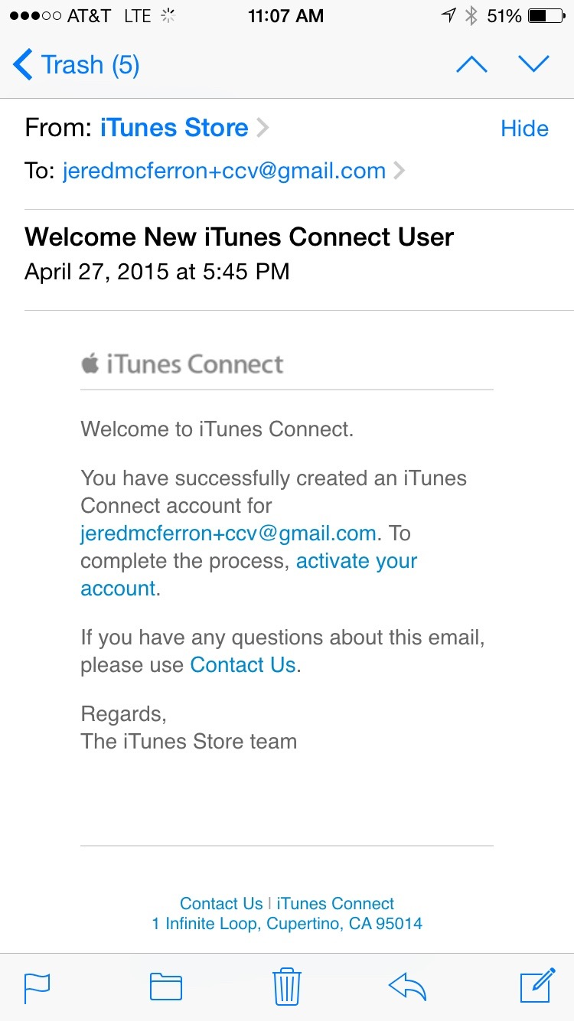

Tap the “activate your account” link, and follow the instructions. Once you complete activation, you will see a webpage that looks like this:

4.

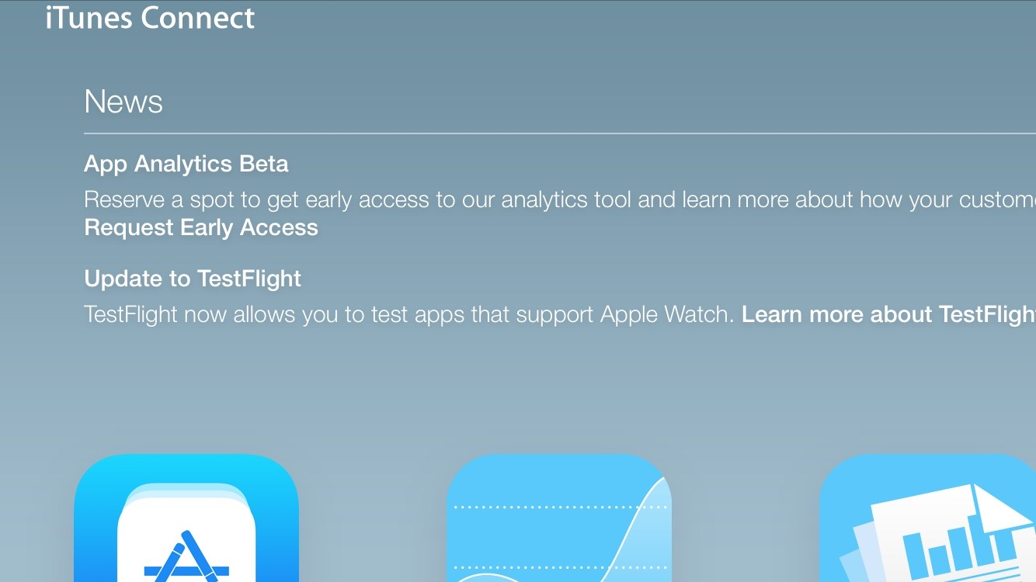

You’re set. You can close that page and forget it ever existed.

5. You will receive a second email from **iTunes Store”** with a subject of “TestFlight: You’re invited to test Christ’s Church of the Valley 2.0”. In that email, there is an “Open in TestFlight” link. Click that.

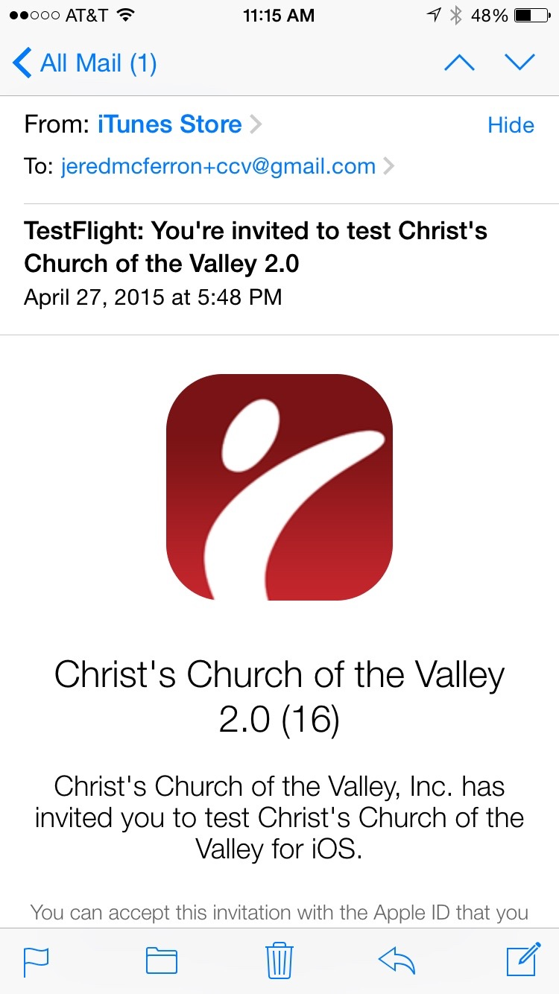

6. You will see an option to Accept and Install the app. Go for it!

